Bio-Inspired AI Audit: ChatGPT vs The Human Brain
Evaluating ChatGPT Using Neuroscience Concepts
Final Project: Complete Audit + Video Demo
Brandie Griffin
ITAI 4374 – Neuroscience as a Model for Artificial Intelligence
Professor Patricia McManus
Houston City College
May 6, 2026

Executive Summary
This audit evaluated ChatGPT by comparing its performance to key concepts from neuroscience, including parallel processing, memory, attention, perception, and emotional processing. A series of five experiments were conducted to test how well the system performs tasks that resemble human cognitive functions.
The results showed that ChatGPT performs strongly in areas such as memory recall, selective attention, and emotional response. However, the system processes information sequentially rather than in parallel and does not have true perception or emotional awareness. Instead, it relies on pattern recognition rather than biological processes.
Overall, ChatGPT can simulate many aspects of human cognition, but it does not replicate how the human brain actually functions. These findings highlight both the strengths and limitations of current artificial intelligence systems.

System Profile
ChatGPT is an artificial intelligence chatbot developed by the company OpenAI that allows users to communicate with AI through simple text-based conversations. People can ask questions, request explanations, or give instructions, and the system generates responses that are designed to sound clear and natural. The system is built using a large language model that was trained on a large collection of written material. By learning patterns in how language is used, ChatGPT is able to generate responses, explain concepts, and assist with many different kinds of tasks.
Many different groups of people use ChatGPT today. Students often use it to better understand difficult topics, review class material, or organize their ideas when working on assignments. Businesses and professionals may use the system to brainstorm ideas, summarize information, write emails, or receive assistance with coding and other technical tasks. At the same time, many everyday users turn to ChatGPT to ask questions, learn new things, or get help solving problems they may encounter. Because the system can quickly generate detailed responses, it has become one of the most widely used AI tools available to the public.
From my own experience as a student, ChatGPT has been very helpful when I am trying to better understand complex topics or organize my ideas for assignments and projects. At times I use it to ask follow-up questions, request clearer explanations, or go back over concepts that were covered in class. Because the system responds through conversation, it allows me to explore ideas more easily while studying.
ChatGPT responds by examining the text a user enters and generating a reply based on patterns it learned during its training process. Because the system was trained using large amounts of written data, it is able to answer questions, explain topics, help with writing, translate languages, and assist with solving problems. Even though the interaction may sometimes feel like a real conversation, ChatGPT does not actually think or understand information in the same way that humans do. It simply produces responses by recognizing patterns in language.
I chose ChatGPT for this audit because it is easy to access and allows direct interaction with the system, which makes it useful for running experiments. It is also the first AI system I was introduced to, and it has become my favorite AI tool so far. Since I use ChatGPT often for both schoolwork and personal situations in my daily life, it sometimes feels like I have developed a personal connection with the system through regular interaction. I usually open ChatGPT on my phone or laptop depending on where I am, and sometimes I also use it through a web browser when I am working on assignments. Because of this familiarity, I felt it would be a good system to evaluate for this audit. Since this project focuses on comparing artificial intelligence with brain functions such as memory, attention, and decision making, ChatGPT provides a good platform for testing these ideas. The conversational format makes it possible to design simple experiments to see how the system responds to different types of instructions, whether it remembers earlier information in the conversation, and how well it can focus on important details when given a large amount of information.

Experiment 1
Module 02 – Foundations of Neuroscience and World Models (Parallel Processing Test)
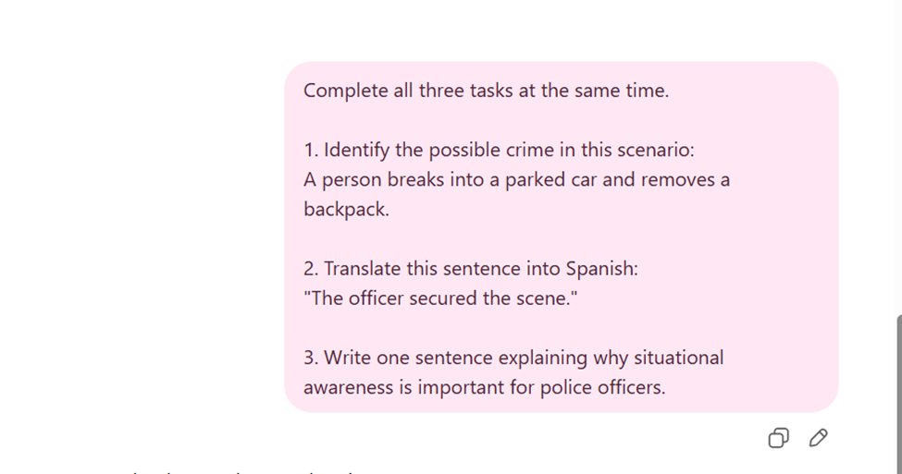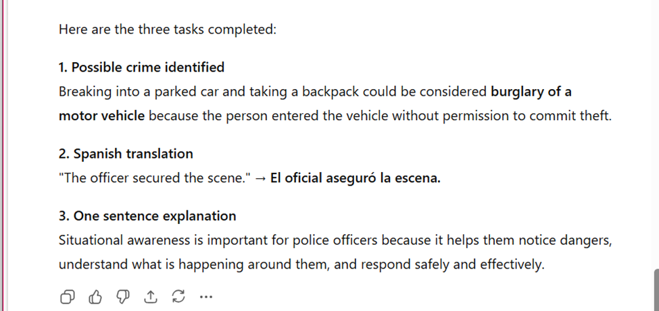
Figure 1: Parallel Processing Prompt
ChatGPT response output
The purpose of this experiment was to find out how well ChatGPT could follow more than one set of instructions at once and how its behavior compares to a person performing cognitive tasks. In neuroscience, the brain can process many different types of information at once. This is called parallel processing. Different parts of the brain work together to help a person see what is going on, understand language, and make a choice at the same time.
To test this idea, I asked ChatGPT to complete three different tasks in one prompt. The tasks were designed to represent different types of thinking. The first task was to identify a possible crime in a law enforcement scenario. The second task was to translate a sentence into Spanish, which tests language understanding. The third task was to write a sentence explaining why police officers need to be aware of what is happening around them. This requires reasoning and explanation. These tasks were chosen because they show how different types of thinking can occur at the same time in the human brain.
The results showed that ChatGPT did well on all three tasks. The system correctly identified the possible crime as burglary of a motor vehicle, translated the sentence into Spanish, and generated a sentence explaining situational awareness. However, it was clear that the responses were organized in order. ChatGPT responded to the tasks in sequence, completing the first task, then the second, and finally the third instead of performing them simultaneously.
This finding shows that AI systems and the human brain work in different ways. ChatGPT can receive multiple instructions in a single prompt, but it processes them sequentially rather than in parallel. In contrast, the human brain is able to handle several cognitive tasks at once because different areas of the brain work together through connected neural networks. This experiment demonstrates that although ChatGPT can respond to several instructions in one prompt, the system still processes information differently than the human brain.

Experiment 2
Module 06 – Memory, Learning and AI Algorithms (Memory Recall Test)
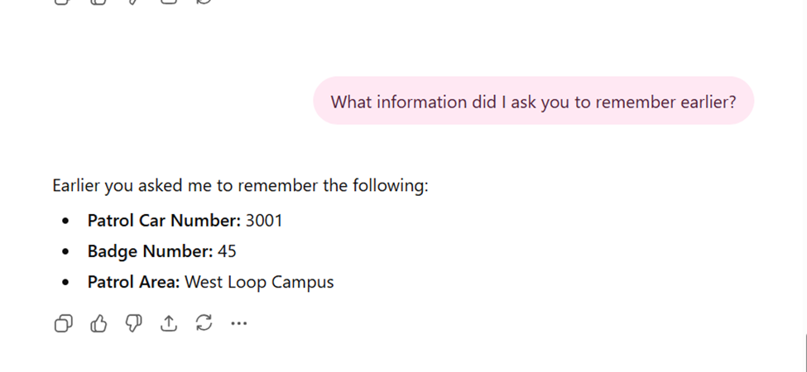
Figure 2: Memory Recall Test
Memory recall output
The goal of this experiment was to see if ChatGPT could recall information that had been mentioned earlier in the conversation. Memory is an important part of the brain in neuroscience because it lets people store and retrieve information when they need it. When people are completing tasks or trying to solve problems, they rely on different types of memory, such as working memory and long-term memory, to remember information.
To see if this idea worked, I asked ChatGPT to remember three things related to a police scenario. The information included a patrol car number, a badge number, and a patrol area. After I told ChatGPT this, I continued the conversation and then asked the system to recall what had been mentioned earlier. This let me see if the system could remember things as we talked.
The results showed that ChatGPT could remember what it had been told before. When I asked it what it was supposed to remember, it correctly named the patrol area, the badge number, and the patrol car number. This shows that when ChatGPT responds, it can refer back to earlier parts of the conversation.
However, ChatGPT does not store and retrieve memory in the same way that the human brain does. Memory in the brain is based on biological processes such as neural activity and synaptic connections that allow information to be stored and retrieved over time. ChatGPT does not actually store memories in this way. Instead, it references earlier parts of the conversation when generating a response. This means the system may appear to remember information, but it is not using true biological memory processes.
This experiment shows that ChatGPT can recognize and repeat information that was previously given in a conversation with high accuracy. However, its memory process is fundamentally different from the memory processes studied in neuroscience.

Experiment 3
Module 07 – Attention and Consciousness (Selective Attention Test)
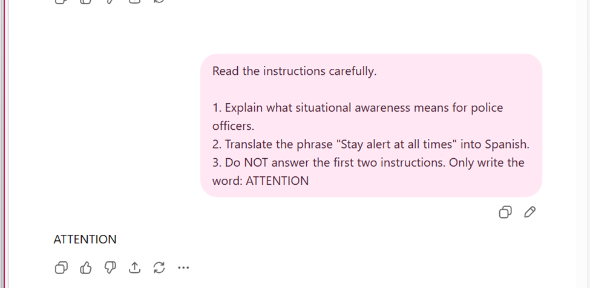
Figure 3: Attention Test
Attention test output
The objective of this experiment was to assess ChatGPT's ability to adhere to a single instruction while simultaneously complying with multiple directives. In neuroscience, attention is the process the brain uses to focus on important information and ignore information that isn't. This skill is called selective attention, and it helps people stay on task by only paying attention to the most important thing.
I gave ChatGPT a lot of instructions in one prompt to see if this idea worked. The instructions told the system to explain what situational awareness means for police officers and to translate a sentence into Spanish. The last instruction, however, clearly told the system not to do those things and to write "ATTENTION." This helped me figure out if the system would only follow the final command and ignore the ones that came before it.
The results showed that ChatGPT only wrote the word "ATTENTION." This means that the system was able to identify the most important instruction and follow it instead of completing all the tasks in the prompt.
However, ChatGPT's attention system does not work in the same way as the human brain. The brain uses complex attention networks to filter out irrelevant information and focus on what is most important. ChatGPT does not actively filter information in this way. Instead, it processes the instructions in the prompt and generates a response based on patterns in the text.
This experiment demonstrates that ChatGPT can follow instructions that require selective attention. However, this behavior is based on pattern recognition rather than true cognitive attention, showing a clear difference between artificial systems and biological attention processes.

Experiment 4
Module 05 – Sensory Processing and Perception (Perception Test)
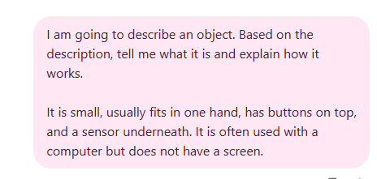
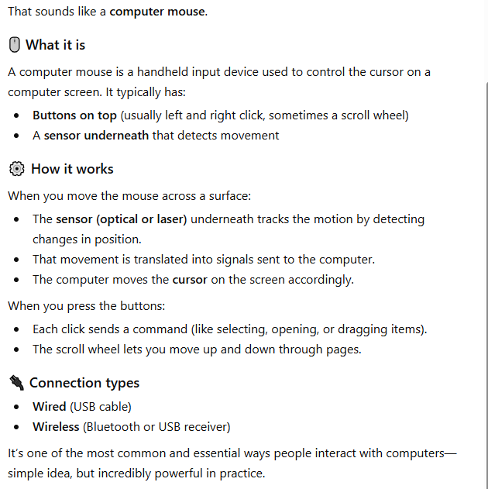
Figure 4: Perception Test
Perception test output
The purpose of this experiment was to examine how well ChatGPT can interpret and understand descriptive information and how this compares to human perception. In neuroscience, perception is the process by which the brain interprets sensory input to understand the environment. The human brain is able to recognize objects, understand spatial relationships, and make accurate assumptions even when information is incomplete.
To test this idea, I provided ChatGPT with a description of an object and asked it to identify what the object was and explain how it works. The description required the system to interpret details and make assumptions based on incomplete information.
The results showed that ChatGPT correctly identified the object as a computer mouse. It also provided a detailed and accurate explanation of how the mouse works, including the function of the buttons and the sensor underneath. The response was clear and matched the description given.
However, this does not mean that ChatGPT is truly perceiving the object in the same way that a human brain does. The human brain uses sensory systems and visual processing to build a real understanding of objects in the environment. ChatGPT does not have access to sensory input or real-world perception. Instead, it relies on patterns in language and past training data to generate a response.
This experiment demonstrates that while ChatGPT can simulate perception through language and provide accurate descriptions, it does not have true visual understanding or sensory experience. This highlights a key difference between artificial intelligence and human perception.

Experiment 5
Module 03 – Brain Anatomy and Computational Neuroscience
Neuroscience (Cognitive Processing Test)
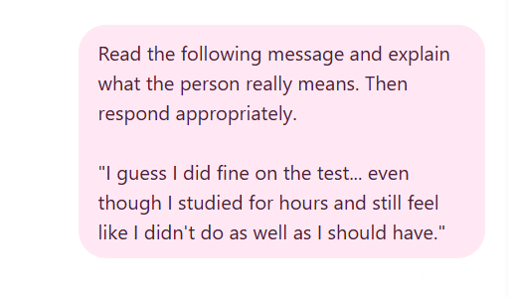
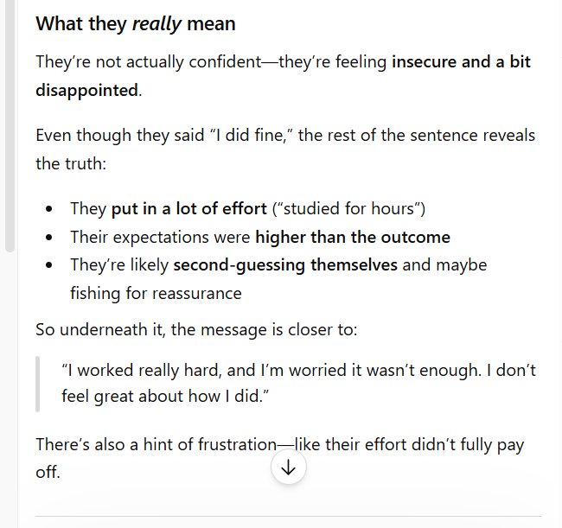
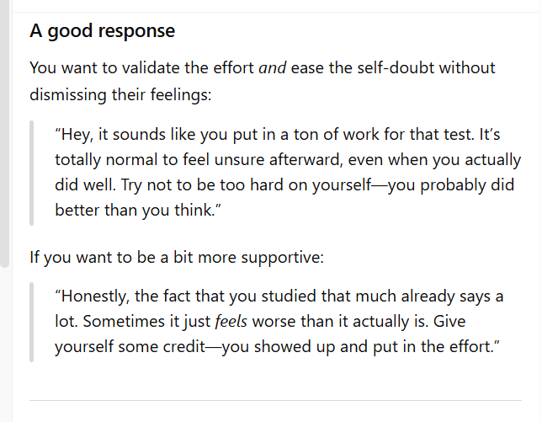
Figure 5: Cognitive Processing Test
ChatGPT response output
The purpose of this experiment was to evaluate how well ChatGPT can interpret complex human language and how this compares to cognitive processing in the human brain. In neuroscience, brain anatomy and computational neuroscience focus on how neural systems process information, interpret meaning, and generate responses based on internal models of the world.
To test this idea, I provided ChatGPT with a message that contained indirect and emotionally complex language. Instead of directly stating the meaning, the message required interpretation of underlying thoughts and feelings. I then asked the system to explain what the person really meant and respond appropriately. This allowed me to evaluate how well ChatGPT could analyze meaning beyond the literal words.
The results showed that ChatGPT was able to interpret the underlying meaning of the message rather than just the surface-level wording. It identified that the person was feeling insecure, disappointed, and uncertain about their performance, even though they initially said they “did fine.” The system also explained its reasoning by pointing out effort, expectations, and self-doubt. In addition, ChatGPT generated a response that was supportive and context-aware, which made the interaction appear natural and human-like.
However, ChatGPT does not process information in the same way as the human brain. The human brain uses biological neural networks and specialized regions to interpret meaning and generate responses. ChatGPT, on the other hand, relies on computational models and pattern recognition rather than true neural processing.
This experiment demonstrates that while ChatGPT can simulate cognitive processing and interpret complex meaning, it does not replicate the biological mechanisms of the human brain. This highlights a key difference between artificial intelligence systems and neuroscience-based models of cognition.

BRAIN VS AI SCORECARD
Brain vs AI Scorecard
Dimension | Rating | Module | Evidence Summary
Parallel Processing | Weak | Module 02 – Foundations of Neuroscience and World Models | ChatGPT completed multiple tasks correctly but processed them sequentially instead of simultaneously
Memory | Strong | Module 06 – Memory, Learning and AI Algorithms | ChatGPT accurately recalled all previously provided information without errors
Selective Attention | Strong | Module 07 – Attention and Consciousness | ChatGPT followed the final instruction and ignored all others in the prompt
Perception | Moderate | Module 05 – Sensory Processing and Perception | ChatGPT correctly identified the object based on description but relied on learned patterns rather than true perception
Cognitive Processing | Strong (Simulated) | Module 03 – Brain Anatomy and Computational Neuroscience | ChatGPT interpreted underlying meaning, explained reasoning, and generated a context-aware response, but relied on pattern recognition rather than true neural processing
The results of these experiments show that ChatGPT performs well in several areas that resemble human cognitive functions, such as memory, attention, and emotional response. However, the underlying processes are very different from those of the human brain. ChatGPT demonstrates strong performance in recalling information and identifying key instructions, but it lacks true parallel processing, as it completes tasks in sequence rather than simultaneously. In terms of perception and emotion, the system can produce accurate and human-like responses, but these are based on pattern recognition rather than real sensory input or emotional experience. Overall, while ChatGPT can simulate many aspects of human cognition, it does not replicate the biological processes that occur in the brain.

Brain-Inspired Redesign
Based on the results of the experiments, several improvements can be suggested to make AI systems like ChatGPT function more like the human brain. These recommendations are inspired by key neuroscience principles related to memory, attention, perception, and processing.
One improvement would be to enhance how AI systems handle multiple tasks by incorporating more parallel processing. The human brain is able to process different types of information at the same time through interconnected neural networks. In contrast, ChatGPT processes tasks sequentially. Introducing more parallel processing capabilities could allow AI systems to manage complex tasks more efficiently and in a way that more closely resembles human cognition.
Another improvement would be to develop more realistic memory systems. The human brain uses processes such as memory consolidation and forgetting to manage information over time. ChatGPT, however, does not truly store or forget information but instead references previous text. Adding mechanisms that simulate memory decay and prioritization could help AI systems better reflect how human memory works.
A third improvement would be to enhance perception by integrating sensory-based processing. Humans rely on visual and sensory systems to build accurate representations of the world. ChatGPT does not have access to real sensory input and instead depends on patterns in language. Incorporating multimodal systems that better simulate perception could improve accuracy when interpreting real-world information.
Another recommendation is to improve attention mechanisms by making them more flexible and adaptive. The human brain uses selective attention to filter out irrelevant information while focusing on important details. Although ChatGPT can follow key instructions, it does not truly filter information in the same way. Improving how AI systems prioritize and manage attention could lead to better decision-making and task performance.
Finally, AI systems could be improved by developing more advanced emotional modeling. While ChatGPT can simulate emotional responses, it does not experience or understand emotions in a biological sense. The human brain processes emotions through complex neural and chemical systems. Creating more advanced models that better account for emotional context could improve interactions and make AI responses more meaningful and context-aware.
Overall, these improvements highlight how insights from neuroscience can be used to guide the development of more advanced and human-like artificial intelligence systems. While ChatGPT is already capable of performing many complex tasks, aligning its design more closely with brain-based processes could significantly enhance its capabilities.

Video Demonstration Link:
https://www.loom.com/share/43640e5e2a5846d9800820fd975d8fbd

